Template for Evidence(s)
UI GreenMetric Questionnaire

University : …..
Country : ….
Web Address : ….

[1] Setting & Infrastructure

[1.8] The ratio of open space area to total area (SI.1)

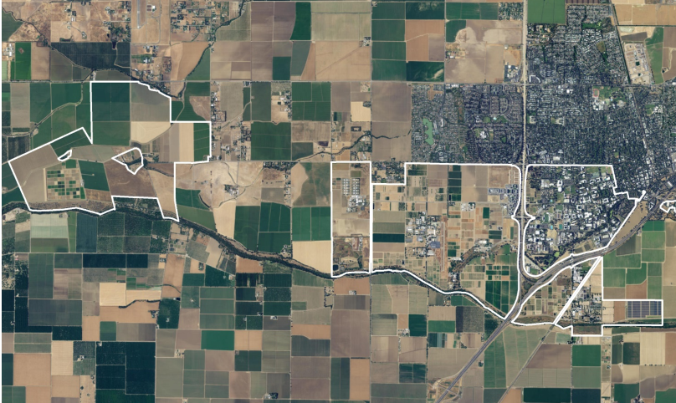

Description:

The evidence provided may also include maps showing the location, area size, or distribution of facilities relevant to the indicators

Ratio of open space towards total area: 96%

Openspace name | Total area | Duration (in Hours per Weeks)
Open Space Preserve | 1.360.000 m² | 84
Putah Creek Riparian Reserve | 2.590.000 m² | 168
UC Davis Arboretum | 404.686 m² | 168

*Example from University of California, Davis

Additional evidence link (i.e., for videos, more images, or other files that are not included in this file):

